W24 Graphql Restaurant

Student: Jose Figueroa

Date: Dec-02-21

Query 1: All Restaurants

{

restaurants{

id

name

}

}

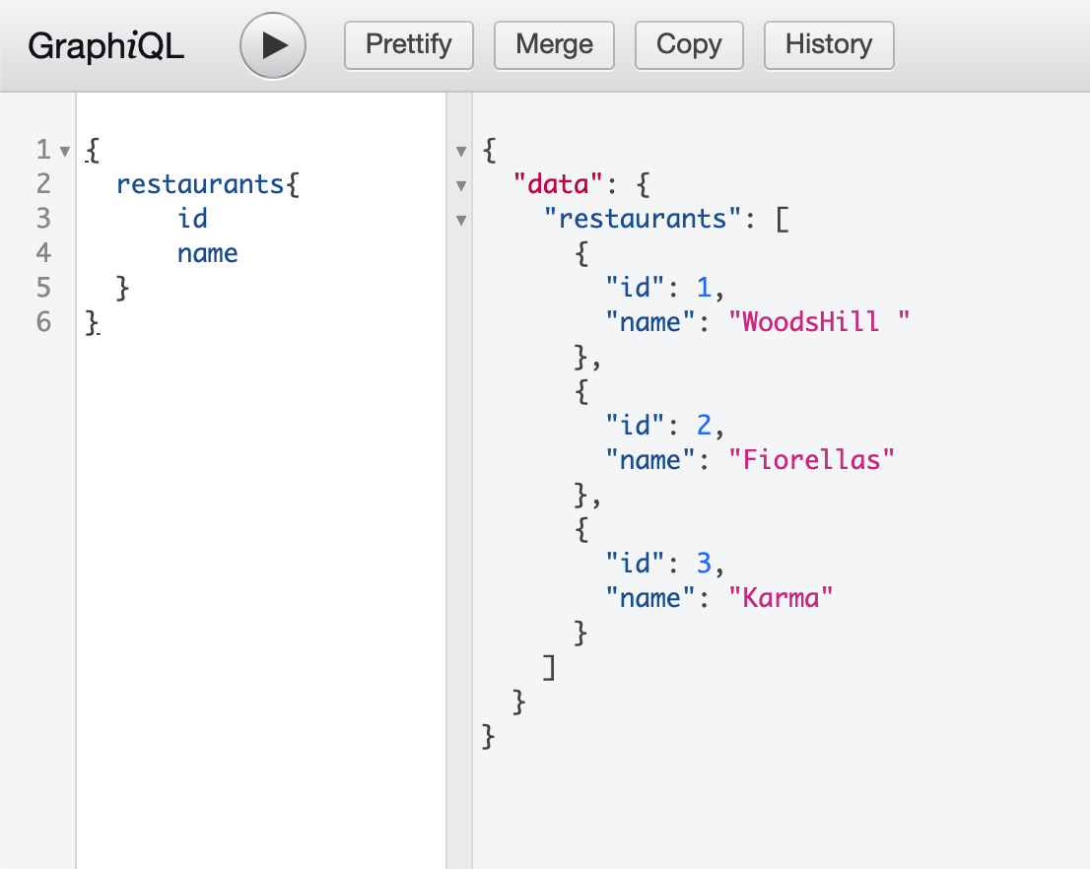

Query 2: One Restaurant by ID

{

restaurant(id:4){

id

name

}

}

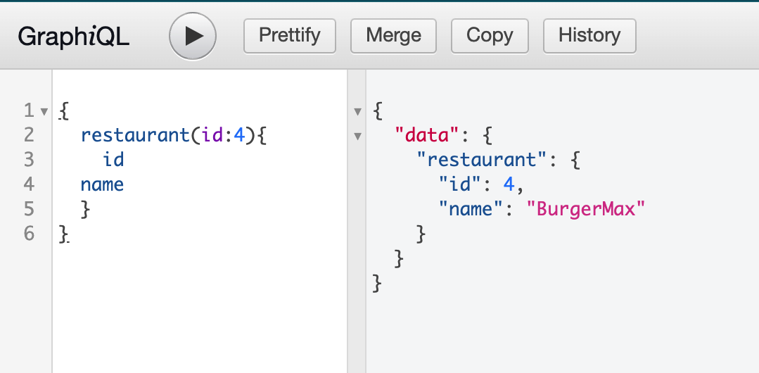

Query 3: Add a restaurant

mutation setrestaurants {

setrestaurant(input: {

id: 4,

name: "BurgerMax",

description:

"Juicy stewed burgers seasoned with a special blend.",

dishes: [

{

name: "Volcano Burger",

price: 18,

},

{

name: "Volcano Burger with Fries ",

price: 22,

},

{

name: "Max Cheeseburger",

price: 16,

},

{

name: "Max Cheeseburger with Fries",

price: 20,

},

],

},) {

id

name

dishes {

name

price

}

}

}

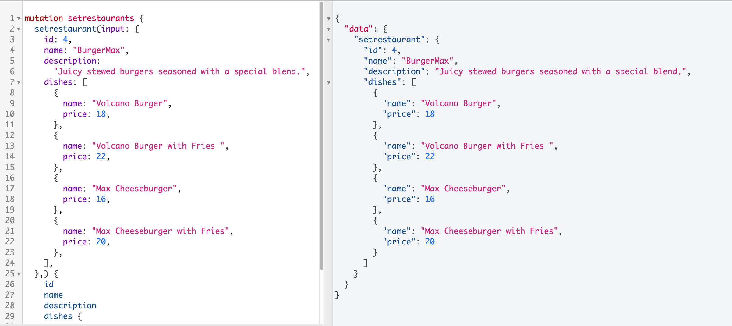

Query 4: Delete a restaurant

mutation deleterest($idd: Int = 4){

deleterestaurant(id: $idd){

ok

}

}

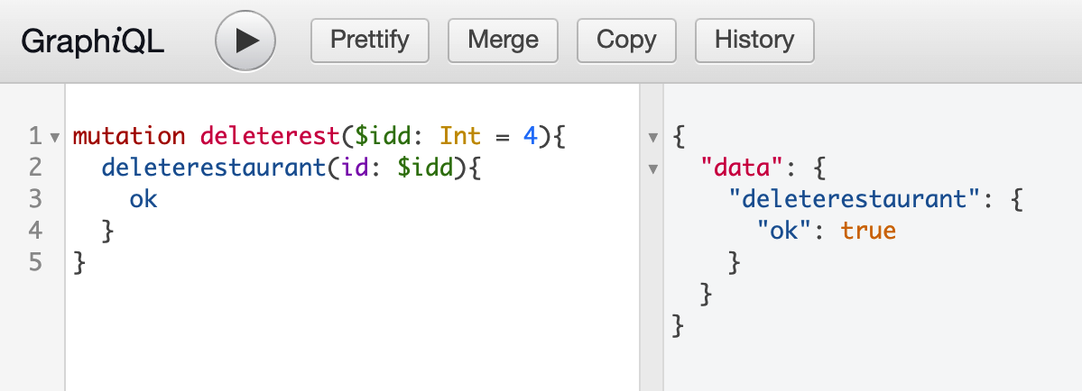

Query 5: Update a restaurant

mutation editrest($idd: Int = 3, $name: String = "BetterKarma"){

editrestaurant(id: $idd, name: $name){

name

}

}

